# CPT_Logo_Manual.jpg Document Libraries

**Lab Time**: 60 minutes

**Lab Overview:** In this lab you will interact with a SharePoint 2010 document library. You will populate an existing library with items and then manage those items by editing and deleting them. You will explore the Check Out process and Version Control feature and how they work together. You will also experiment with content approval and the state of a new item.

## Exercise 1: Manipulating Document Library Items

In this exercise you will populate an existing document library on the Products Team Site with items then manage those items by editing them and eventually deleting them.

1. Log into your site collection using the account **Janice Galvin**.
2. Using Internet Explorer, browse to the URL of the SharePoint site collection you were provided to use when working on the hands on labs in this course.
3. When prompted to login, enter [[AD-DOMAIN]]\janice in the **User Name** field and click **OK**. Use the password specified in the *Hands-On Lab Overview* document provided in the student manual.

**Note**: if you are not prompted to login & if you are logged in as another user use the Welcome Menu to logout and login as a different user.

1. Navigate to the Wingtip Team **Products** Site and visit the site's **Shared Documents** library.

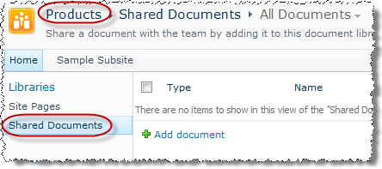

1. Organize the library into folders:
2. Click the **Documents** tab in the contextual tab group **Library Tools** of the ribbon at the top of the page.
3. Use the **New Folder** button to create a new folder named **Toy Specs**.

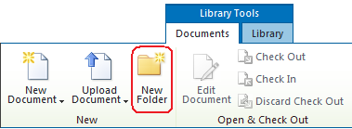

1. After entering the name **Toy Specs** in the text box, click the **Save** button to complete folder creation.
2. Upon creating the folder, note that your browser remains focused on the Shared Documents library's root level. There is no need to re-navigate back to the root before creating additional folders at the same level of the library as the Toy Specs folder.

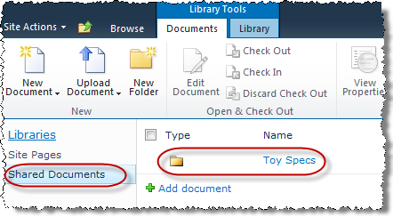

1. Repeat the previous steps to create two additional folders in the Shared Documents library named **Employee****Information** & **Manufacturing Documents**.
2. Using **Notepad** on your workstation, create a new file named HotToReadSpecs.txt and add some content to it (it can be anything, but it must contain at least one character). Save this file to the desktop.
3. Use the **Upload Document** button in the **Documents** tab within the ribbon to upload a single existing file named HowToReadSpecs.txt:
4. Navigate to the **Toy Specs** folder of **Shared Documents** by clicking on the name of the folder that appears in the library's root.
5. Click the **Upload Document** link in the **Documents** tab within the ribbon at the top of the page to open the **Upload Document** dialog box.
6. Use the **Browse** button to browse to the desktop and select the HowToReadSpecs.txt file and either double-click the file name or click the **Open** button.

**Note**: Instead of using the browse button you could simply type the entire path and file name in the **Name:** field of the **Upload Document** dialog box.

1. Now that the path and filename appear in the **Name:** field of the **Upload Document** dialog box.

Notice that if you needed to upload more than one file you could change your mind by clicking the **Upload Multiple Files...** hyperlink that appears in fine print underneath the **Name:** field. **DO NOT** click this link at this time since you are only uploading a single file right now.

1. Note that the **Overwrite existing files** checkbox is already checked, meaning that if there is already a file in the **Toy Specs** folder that is also named HowToReadSpecs.txt then the file you are uploading will replace that file (even if that file contains completely different or unrelated text content). Leave this box checked as this is the first occurrence of a HowToReadSpecs.txt document into the library.
2. Notice that the **Destination Folder** value has already been filled in with the **Toy Specs** folder (because you were already in the folder before starting the upload process). However the **Choose Folder** button allows you to change your mind at the last minute before uploading the document to place the file into another folder. Leave this value set to the **Toy Specs** folder.

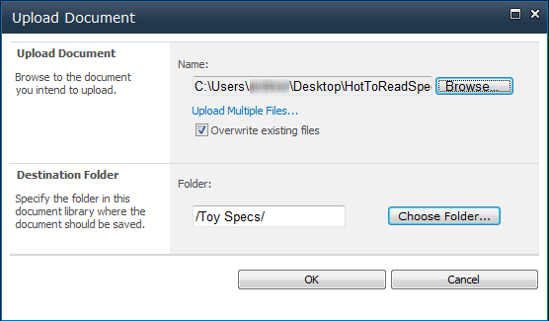

1. Click the **OK** button to complete the upload of the HowToReadSpecs.txt document into the **Toy Specs** folder of the **Shared Documents** library. The page will return to the Toy Specs folder and should show your new item in it.
2. Use the **Upload Multiple Documents** link in the drop-down menu of the **Upload Document** button found in the **Documents** ribbon at the top of the page to upload multiple existing files named ElectronicsSpec.docx and MechanicalSpec.docx from the file system.
3. Create two new files using Microsoft Word named ElectronicSpec.docx and MechanicalSpec.docx, add some text to each and save them to the desktop.

**Note**: You can use any version of Microsoft Word if you don’t have the latest version installed on your workstation.

1. You should still be in the **Toy Specs** folder from the previous step. If you are not, browse to the **Toy Specs** folder of the **Shared Documents** library by using the breadcrumb trail to return to the root of the **Shared Documents** document library if necessary before clicking the Toy Specs folder.
2. Click the drop-down arrow in the lower right corner **Upload Document** link in the **Documents** tab within the ribbon then choose **Upload Multiple Documents** to open the **Upload Multiple Documents** dialog box:

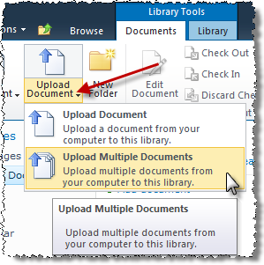

**Note**: If you don’t have Office 2010 installed your experience will not look the same as above. Instead you will have a Windows Explorer like experience. Both work the same except the newer experience shown in the previous screenshot is more appealing and provides more visual feedback. The next few steps may vary depending on if you have Office 2010 installed or not.

1. SharePoint integrates with the user’s workstation to provide the opportunity for you to drag and drop files or entire folders from the file system into the dialog box. Open **Windows Explorer** (**START » All Programs » Accessories » Windows Explorer**) and browse to the desktop, then position it so that you can see both the **Upload Multiple Documents** dialog box of SharePoint and the desktop contents.

**Note**: This may require taking the Internet Explorer window out of Maximize.

Using the [CTRL] key on your keyboard, highlight the ElectronicsSpecs.docx file and the MechanicalSpecs.docx file simultaneously in Windows Explorer. Then click and hold your left mouse button to drag the two files into the blue area of the **Upload Multiple Documents** dialog box.

1. Once the two files appear in the **Upload Multiple Documents** dialog box, note the file size indicator now represents the total size of the two files.
2. Note that the **Overwrite existing files** checkbox is already checked, just like when you upload a single document. Leave this box checked.
3. Notice that the **Destination Folder** value has already been filled in with the **Toy Specs** folder (because you were already in the folder before embarking on the Upload Document process). The **Choose Folder** button allows you to change your mind at the last minute before uploading the document and place the file in another folder. Leave this value set to the **Toy Specs** folder.

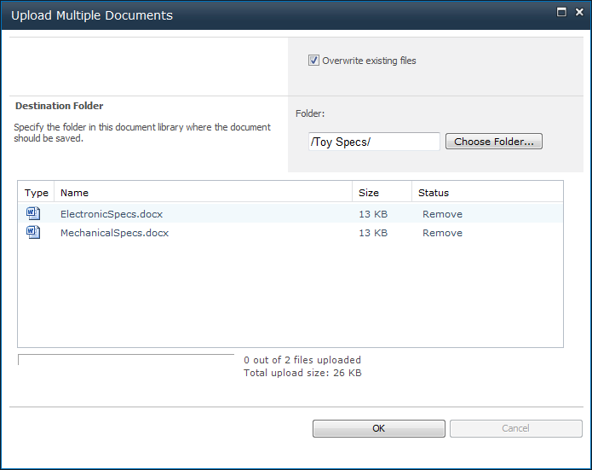

1. Click the **OK** button to complete the upload of the ElectronicsSpecs.docx and MechanicalSpecs.docx documents into the **Toy Specs** folder of the **Shared Documents** library.
2. When the process has uploaded the files, click the **Done** button (which used to say OK, but changed when the process was complete).
3. Upload additional documents to the **Shared Documents** library:
4. Using Microsoft Word & Excel create a few more files and add content to these: Product Employees Ethics.docx & Product Employees Schedule.xlsx.
5. Repeating the previous steps, Use the **Upload Multiple Documents** button in the **Documents** tab within the ribbon to upload the two new files you just created to the **Employee Information** folder of the **Shared Documents** library.
6. Create a new document in the **Manufacturing Documents** folder:
7. Navigate to the **Manufacturing Documents** folder by first using the breadcrumb trail to return to the root of the **Shared Documents** document library, then clicking the **Manufacturing Documents** folder.
8. Click the **New Document** button in the **Documents** tab in the ribbon at the top of the page which will automatically launch the client application associated with the default document template setting on the Shared Documents library: Microsoft Word.

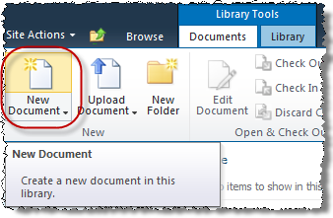

**Note**: Microsoft Word may prompt you to login again. This is because Word is requesting the template for the document library which lives in SharePoint. It isn’t likely that you are in the same Active Directory Domain as the SharePoint lab environment. Therefore it can’t reuse the credentials you used to login to your workstation. Nor can it use the credentials you used to login to the site as those are tied to the browser, not Word.

1. When Microsoft Word opens, click the **Enabled Editing** button just below the ribbon to edit the document.
2. Enter a few lines of text in the new Word document.
3. Save the document. When saving Word may default to saving to your local workstation. This isn’t what you want. You’d rather save to the document library. To do this, you may need to enter the URL of your site collection’s **Products** site (for example: http://[..]/sites/[..]/Products) and navigate down to the **Shared Documents Library** & **Manufacturing Documents** folder. The following figure demonstrates how you can do this within Microsoft Windows 7. Give the document a name of **My Manufacturing Document**.

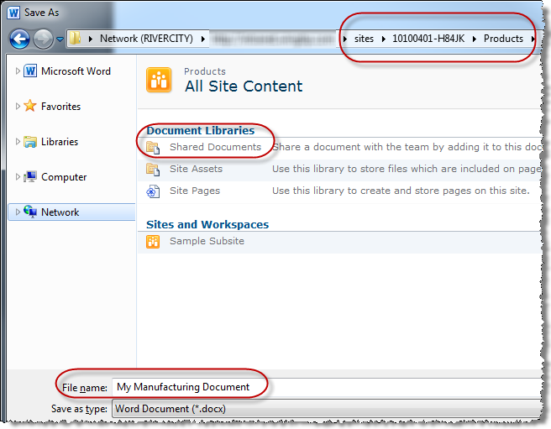

1. Verify that your new document appears in the **Manufacturing Documents** folder of the **Shared Documents** library using the browser.
2. Edit an existing spreadsheet in the **Employee Information** folder:
3. Navigate to the **Employee Information** folder by first using the breadcrumb to return to the root of the **Shared Documents** document library, then clicking the **Employee Information** folder
4. Open the Products Employee Schedule.xlsx spreadsheet by hovering over the item's **Name** until a drop-down arrow appears to the right of the name (*DO NOT click the name, just hover over it*). Use the drop-down arrow to open a contextual item menu called the *Edit Control Block (ECB) Menu* and choose **Edit in Microsoft Excel**. Microsoft Excel will be automatically launched with the spreadsheet loaded.

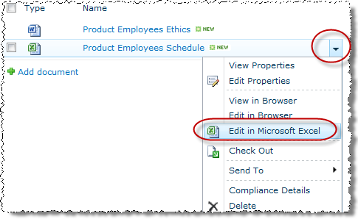

1. Add some contents, then save your changes and exit Excel.
2. Verify that the **Modified Date** have been altered on the document in the **Employee Information** folder of the **Shared Documents** library to reflect your change.
3. Delete an existing document from the **Manufacturing Documents** folder using the item's ECB menu:
4. Navigate to the **Manufacturing Documents** folder by first using the breadcrumb return to the root of the **Shared Documents** document library, then clicking the **Manufacturing Documents** folder.
5. Hover over the **My Manufacturing Document** item's **Name** until the drop-down arrow for the ECB menu appears. Use ECB Menu and choose **Delete**.
6. Click **OK** in the pop-up prompt to confirm deletion of the item to your SharePoint Recycle Bin.

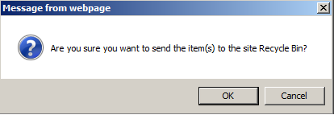

1. Verify that the item no longer appears in the **Manufacturing Documents** folder.
2. Restore a deleted item from your **Recycle Bin**:
3. Click the **Recycle Bin** link in the Quick Launch bar:

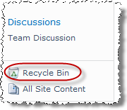

1. Check the selection box for your **My Manufacturing Document** item and click the **Restore Selection** button in the Recycle Bin toolbar:

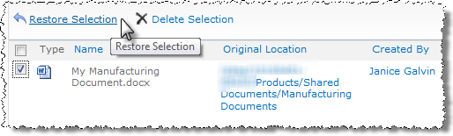

1. Click **OK** in the pop-up prompt to confirm restore of the item to its origin location.
2. Go back to the **Shared Documents** **Manufacturing Documents** folder and verify the contents have been restored.
3. Delete an existing folder and its contents from the **Shared Documents** library:
4. Navigate to the root of the **Shared Documents** library on the **Products** site using the **Quick Launch Bar**.
5. Check the selection checkbox for the **Manufacturing Documents** folder and click the **Delete** button in the **Manage** group of the **Documents** tab in the ribbon to delete the folder and its contents.

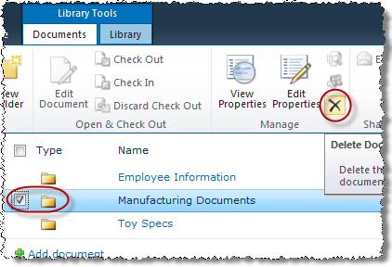

1. Click **OK** in the pop-up prompt to confirm deletion of the folder to your SharePoint Recycle Bin.
2. Verify that the folder no longer appears in the Shared Documents folder.

In this exercise you learned populate a document library with items and manage them.

## Exercise 2: Check Out and Version Control

In this exercise you will explore the Check Out and Version Control features of a SharePoint document library. You will also witness interoperability between Microsoft Word 2010 and SharePoint 2010.

1. Navigate to the **Research Items** document library on the **Products** site by All Site Content link in the Quick Launch Bar and make sure you are logged in as [[AD-DOMAIN]]\Janice.
2. Open the **Hazardous Chemical Information** item for reading purposes only.
3. Click the item's Name: **Hazardous Chemical Information** to open the document in Microsoft Word.
4. Microsoft Word 2007 *(those using Word 2010 will not see this prompt)* will prompt you asking if you want to open the document in read only mode. This is because the Research Files document library is enforcing Check-Out of any item opened for edit purposes. Select Read Only and click OK.

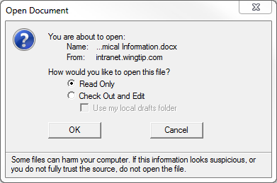

1. When Word opens, click the **Enable Editing** button in the area below the ribbon.
2. In order to save any changes to the document, you will need to check it out. Leave the document open in Read-Only view for next step; **Do NOT click Check Out**.

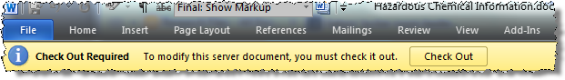

1. Edit a document you have already opened in Read Only view:
2. Click the **Check Out** button in the **Document Information Panel** to check out the file from the document library on the fly. Notice that the Read-Only designation disappears from the file name at the top of the Microsoft Word window and that the file is now editable.
3. Add a line to the document describing how you achieved check out and **Exit Microsoft Word** (DO NOT simply close the document or minimize the window) without saving or closing the document.
4. Click **Save** in the pop-up prompt to save your work.

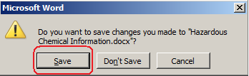

**Note:** Word may prompt you to check the document in. If so, click **No** leaving the document checked out.

1. You may need to refresh the page to see the document is checked out.
2. Go back to the browser and select the document. From the **Library Tools » Documents** tab in the ribbon, select **Check In** from the **Open & Check Out** group.

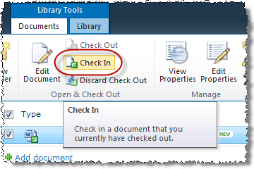

**Note:** You may need to refresh the page to see the item is now checked out.

1. In the next dialog, select to save the document as a major version and pick **No** for the **Retain Check Out** option. Add some comments and click **OK**.

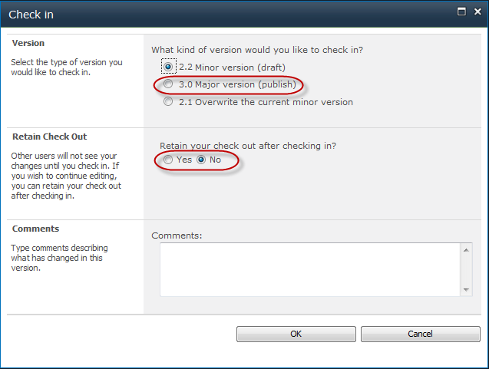

1. **Check Out** the **Hazardous Chemical Information** item from the library using the Documents ribbon as a different user: Ken Sanchez.
2. From the **Welcome Menu** in the top-right corner of the page, select on **Sign in as Different User**.
3. Enter [[AD-DOMAIN]]\ken for a User Name & click **OK**. Use the password specified in the *Hands-On Lab Overview* document provided in the student manual.
4. Check the checkbox for the **Hazardous Chemical Information** item and click the **Check Out** button in the **Open & Check Out** group of the **Documents** tab in the ribbon:
5. Click **OK** in the pop-up prompt to confirm you wish to check out the item. Note the checkbox that would allow SharePoint to place a temporary working copy of the file into a local drafts folder on your client pc from which you could work (just in case you were to lose connectivity to the SharePoint server). Leave this checkbox UNCHECKED to work with the server copy.

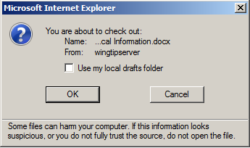

1. Notice the document’s icon has changed to show it is now checked out:

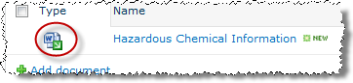

1. Once the item has been checked out to Ken, re-authenticate into the library as Janice by using the **Sign in as Different User** link in the **Welcome Menu** again to sign back into the library as Janice Galvin: [[AD-DOMAIN]]\janice. Verify that a small green arrow appears on the item's type icon and that, when you hover your mouse over this icon, a tool tip appears indicating that the item is checked out to Ken.

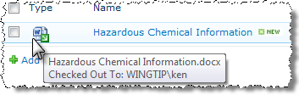

1. Attempt to edit the document that has been checked out by another user:
2. Check the selection box for the **Hazardous Chemical Information** item and click the **Edit Document** button in the **Open & Check Out** group of the **Documents** tab in the ribbon. Microsoft Word will launch and the file open process will result in a pop-up prompt warning that the item is checked out to another user.

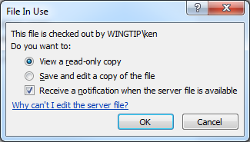

1. Leave the radio button to **View a read-only copy** selected and leave the checkbox checked to **Receive a notification when the server file is available**. The notification will appear in the Document Information Panel of your Read-Only view copy when Ken completes the check in process on his edited rendition.
2. Exit Microsoft Word (you should not receive a prompt to save any work since you were only viewing the document in Read-Only view).
3. Check in the Hazardous Chemical Information item back into the Research Files library as Ken Sanchez.
4. From the **Welcome Menu** in the top-right corner of the page, select on **Sign in as Different User**.
5. Enter [[AD-DOMAIN]]\ken for a User Name & click **OK**. Use the password specified in the *Hands-On Lab Overview* document provided in the student manual.
6. Check the selection box for the **Hazardous Chemical Information** item and click the **Check In** button in the **Open & Check Out** group of the **Library Tools » Documents** tab in the ribbon.
7. In the next pop-up prompt to **Check In** the item back into the library, select to check in Ken's rendition of the file as the next available **Major Version** number, 3.0, and enter some comments then click **OK**.
8. The Web page may not have refreshed and may still erroneously indicate that the **Hazardous Chemical Information** item is checked out of the library. Before assuming this to be true, click on the **Refresh** button in the browser get a refreshed copy of the page. Verify that the **Hazardous Chemical Information** item is no longer checked out (for example, there is no green arrow on the file type icon).

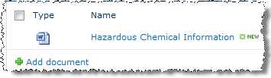

1. Check Out a document on the fly by using the Edit Document button in the Documents tab in the ribbon:
2. Check the selection box for the **Hazardous Chemical Information** item and click the **Edit Document** button in the **Open & Check Out** group of the **Documents** tab in the ribbon.
3. Click **OK** in the pop-up prompt to confirm you wish to check out the item. Microsoft Word will automatically launch and open the file.
4. Leave the Microsoft Word window up and running but return to the Internet Explorer window open to the **Research Files** document library. Refresh the Web page and note the green arrow on the item's type icon indicating that the item is now checked out. Hover over the type icon and read the tool tip stating the item is checked out to you.
5. Return to the Microsoft Word window and add a line describing how you opened the file in edit view. Then click on the **File** tab and click the **Check In** option to Check In the item back into the library without saving the file first. Microsoft Word will automatically save the file before checking it into the library.

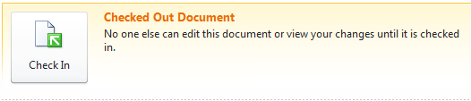

1. In the next pop-up prompt to **Check In** your item back into the library, select to check in your newly edited rendition of the file as the next available **Minor Version** number, **3.1**, and enter some comments describing what changes have been made to the document.
2. Exit Microsoft Word.
3. You should still have a browser window open to the **Research Files** document library. The Web page may not have refreshed and may still erroneously indicate that the **Hazardous Chemical Information** item is checked out of the library. Before assuming this to be true, click on the **Refresh** button in the browser to get a refreshed copy of the page. Verify that the **Hazardous Chemical Information** item is no longer checked out and that its **Modified** value reflects the recent edit date and time.
4. View the Version History of the Hazardous Chemical Information document:
5. Check the selection box for **Hazardous Chemical Information**, click the **Version History** button in the **Manage** group of the **Documents** tab in the ribbon.

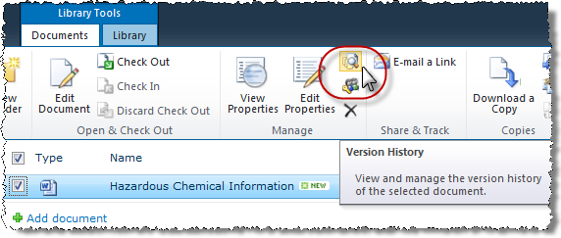

1. In the resulting **Version History** dialog box, notice all of the versions that have been saved of the **Hazardous Chemical Information** document. Also note that from the toolbar of this dialog box you can quickly delete all versions of the document or all minor versions of the document (while retaining the major versions).

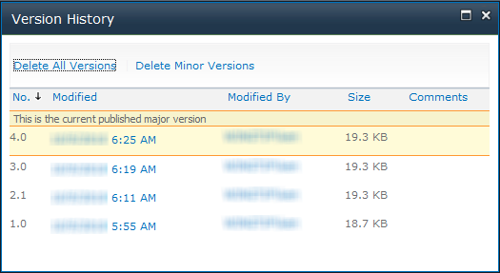

1. Hover over any version's **Modified date/time** stamp and use the drop-down arrow to the right of the date/time value to open the version's contextual menu. From this menu you can view the version's metadata properties or restore the version to the library (*this will demote the current published version and replace it in the library but NOT OVERWRITE IT*). If the version is a Major version, you can even choose to Unpublish the major version, downgrading it to a minor version (if the library supports minor versions, otherwise deleting it) of the item.

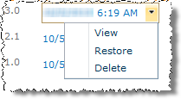

1. Open the previous 2.0 version of the document for reading purposes by clicking on its Modified date/time stamp.
2. Microsoft Word will automatically launch and open the file in Read-Only view and give you the opportunity to compare it to another version before deciding whether to delete or restore it.
3. Exit Microsoft Word and **Close** the **Version History** dialog box.
4. Publish the Minor Version 3.1 of the Hazardous Chemical Information document:
5. You should still have as browser window open to the **Research Files** document library from the previous step. If not, navigate to the **Research Files** document library.
6. Check the checkbox for the **Hazardous Chemical Information** item and click the **Publish** button in the **Workflows** group of the **Documents** tab in the ribbon.
7. Enter comments for the new major version of the item and click **OK** in the pop-up prompt to **Publish Major Version**.
8. Verify the new version in the item's Version History.
9. Return to the **Products** site home page via your preferred navigation method.

In this exercise you explored the two document management features in SharePoint: Check Out and Version Control.

## Exercise 3: Approving Library Content & Workflows

In this exercise you will engage with a document library that has the Content Approval option enabled and witness the effects on adding documents. You will also create and test a simple Approval Workflow.

1. Navigate to the **New Products Documents** document library on the **Products** site by using the library's link in the Quick Launch Bar.
2. Create a new document into the library as Janice Galvin:
3. Authenticate into the library as Janice Galvin using the **Welcome Menu** in the top right corner and select **Sign in as Different User** and enter [[AD-DOMAIN]]\janice for the user name and click **OK**.
4. Click the **New Document** button in the **Documents** tab in the ribbon at the top of the page which will automatically launch the client application associated with the default document template setting on the New Products Documents library: Microsoft Word.
5. Enter a few lines of text and save the file as **My New Product Document**.
6. Exit Microsoft Word.
7. Return to the browser and navigate to the **Products** site then to the **New Products Documents** document library if you aren’t already there.
8. Notice that Janice can see her own document.
9. Attempt to read the new item as Michael Sullivan:
10. Authenticate into the library as Michael Sullivan using the **Welcome Menu** in the top right corner and select **Sign in as Different User** and enter [[AD-DOMAIN]]\michaelsfor the user name and click **OK**.
11. Browse to the **New Products Documents** document library within the **Products** site.
12. Note that Michael also cannot see the pending item because it has not yet been approved.
13. Approve the new item as Rob Walters:
14. Authenticate into the library as Rob Walters using the **Welcome Menu** in the top right corner and select **Sign in as Different User** and enter [[AD-DOMAIN]]\rob for the user name and click **OK**.
15. Browse to the **New Products Documents** document library within the **Products** site.
16. Note that Rob can see the pending item because he is a member of a special group called **Approvers** that has the permission to approve items throughout all sites and libraries in the Wingtip Team Site.
17. Select the document **My New Product Document**. Begin the approval process by clicking on the **Approve/Reject** button in the **Workflows** group of the **Library Tools »** **Documents** tab in the ribbon:

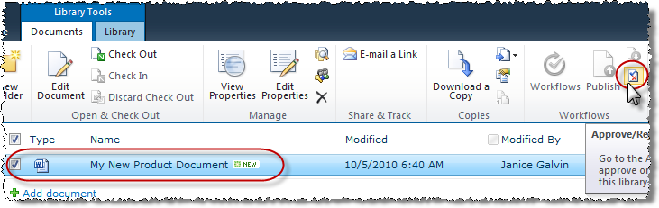

1. In the resulting **Approve/Reject** dialog box, select the **Approved** radio button and enter a comment indicating Rob likes the document.
2. Click **OK** to complete the approval and notice that in the library the item's **Approval Status** value has changed from **Pending** to **Approved**.

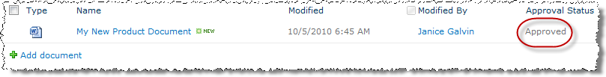

1. Attempt to read the new item as Michael Sullivan again:
2. Authenticate into the library as Michael Sullivan using the **Welcome Menu** in the top right corner and select **Sign in as Different User** and enter [[AD-DOMAIN]]\michaelfor the user name and click **OK**.
3. Browse to the **New Products Documents** document library within the **Products** site.
4. Note that Michael can now see the new item because it has been approved.
5. Authenticate into the library as Rob Walters using the **Welcome Menu** in the top right corner and select **Sign in as Different User** and enter [[AD-DOMAIN]]\rob for the user name and click **OK**.
6. Now you must configure the Approval workflow on the **Product Notices** document library. To this using the following steps:
7. Navigate to the Product Notices document library in the **Products** site by selecting **View All Content** from the site’s **Quick Launch Bar** and selecting the **Product Notices** library.
8. In the ribbon, select **Library Tools » Library**. Within the **Settings** group, click the down arrow for the **Workflow Settings** button and select **Add a Workflow**:

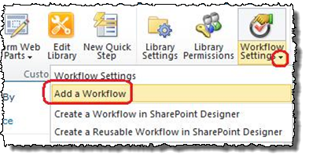

1. The next page contains a form to create a new workflow association on the document library. Use the following information to create a new workflow association (leaving all fields not mentioned to their default values) and click **OK**:

**Workflow:** Approval – SharePoint 2010

**Name:** Notice Approval

**Start Options:** Check **Allow this workflow to be manually started by an authenticated user with Edit Item Permissions** & **Start this workflow when a new item is created**.

1. On the next page you will need to configure the workflow specific settings. Use the following information to configure the workflow (leaving all fields not mentioned to their default values) and click OK:

**Approvers / Assign To:** SBO\Rob; SBO\Ken (*see the note after this step before proceeding!*)

**Enable Content Approval:** Checked

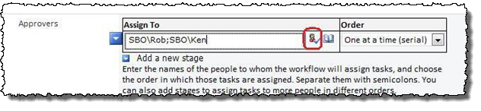

**Note:** When entering the approvers, it is important to list Rob & Ken in the order listed in the step. After entering their names, click the Check Names icon to validate their names

1. Authenticate into the library as **Ken Sanchez** using the **Welcome Menu** in the top right corner and select **Sign in as Different User** and enter [[AD-DOMAIN]]\ken for the user name and click **OK**.
2. Navigate to the **Product Notices** document library on the **Products** site by selecting **View All Content** from the site’s **Quick Launch Bar** and selecting the **Product Notices** library. This library has an Approval workflow named **Notice Approval** on it that routes new items to Rob Walters for initial approval, then on to the Ken Sanchez for final approval.
3. Create a new document into the library as Janice Galvin.
4. Authenticate into the library as Janice Galvin using the **Welcome Menu** in the top right corner and select **Sign in as Different User** and enter [[AD-DOMAIN]]\janicefor the user name and click **OK**.
5. Use Microsoft Word to create a new document Announcing Product 12022.docx, add some content and save it to your desktop.
6. Upload this document to the **Product Notices** document library.
7. Verify creation of the new item by Janice Galvin and note the item's status for the **Notice Approval** workflow (it should state the workflow is **In Progress**):

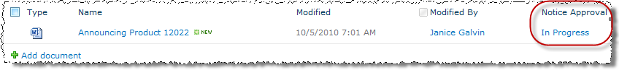

1. Navigate to the **Tasks** list on the **Products** site by using the Quick Launch Bar. Let’s now manage the new task item that the Notice Approval workflow created and assigned to Rob:
2. Notice the new task item assigned to Rob directing him to approve the new document:

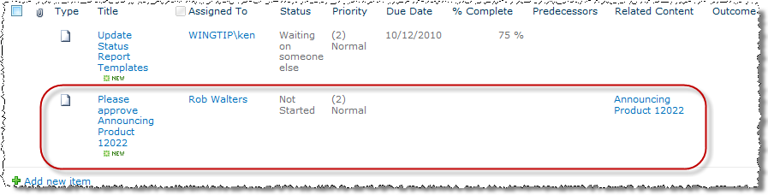

1. Login as Rob Walters:
2. Authenticate into the library as Rob Walters using the Welcome Menu in the top right corner and select **Sign in as Different User** and enter [[AD-DOMAIN]]\robfor the user name and click **OK**.
3. Look at the **Announcing Product 12022** file by clicking its hyperlink in the **Related Content** column. Click **Open** in the resulting pop-up to open the file in Read-Only view in Microsoft Word. Once you've glanced at it, Exit Microsoft Word.
4. Click on the Task item's **Title** hyperlink to produce the **Workflow Task** dialog box.

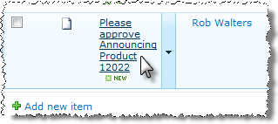

1. Click the **Approve** button in the **Workflow Task** dialog box to approve the new document. The workflow will edit Rob’s task by changing the **Status** column value from **Not Started** to **Completed** and changing the **% Complete** column value from **0%** to **100%**.

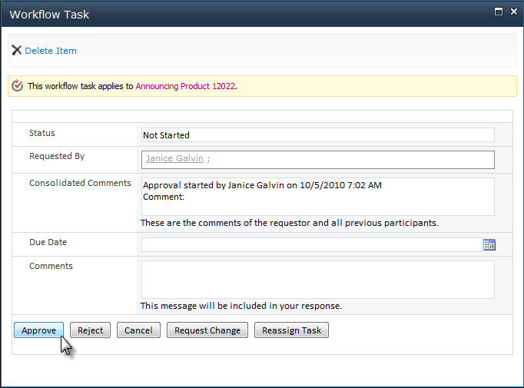

1. Notice that the workflow automatically creates a new task assigned to Ken Sanchez requesting approval for the same new document. This is because Ken’s user account was the second Assignee in the Workflow and the workflow routes new product notices first to Rob, then to Ken (this is called a *serial* route because Rob must approve the item before Ken even hears about it). Leave this new task item alone.

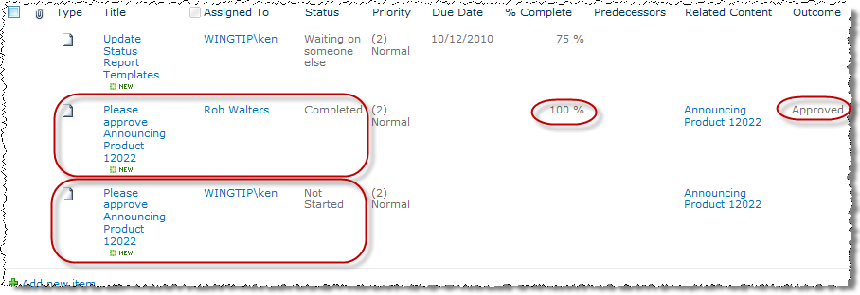

1. Login as Janice Galvin:
2. Authenticate as Janice Galvin using the **Welcome Menu** in the top right corner and select **Sign in as Different User** and enter [[AD-DOMAIN]]\janice for the user name and click **OK**.
3. Navigate to the **Product Notices** document library on the **Products** site by using the library's link in the Quick Launch Bar. Explore the item's workflow state:
4. Click the hyperlink of the **Notice Approval** workflow column on the **Announcing Product 12022** item to navigate to the **Workflow Information** page of the **Notice Approval** workflow. This page exposes metadata about the workflow object itself including who and what caused it to initiate, when it initiated, a Microsoft Visio diagram of the workflow (*if Visio Services is enabled on the server*), the Tasks list items generated by the workflow and the Workflow History of every step the workflow has completed to date (which was omitted from the following picture to save space on the page but you should see details on your screen):

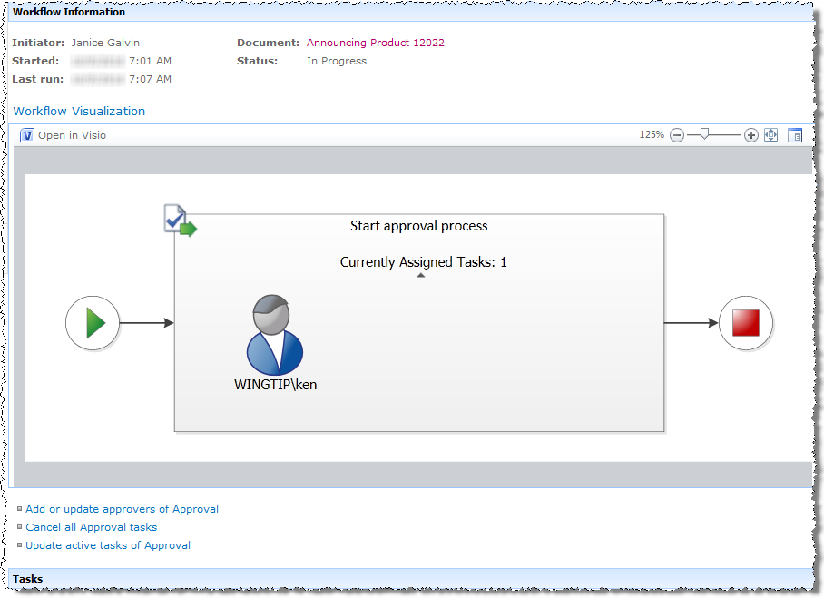

1. Repeat steps 12-15 except login in as Ken Sanchez ([[AD-DOMAIN\Ken) to complete the workflow.

In this exercise you practiced content approval on a document library using both the Content Approval library option and a simple workflow.